Final Year Project

(Advisor: Sohail Imran)

#### 

#### 

#### Project Planning System

Anees Ahmed (58875) - MCS

Table of Contents

I. Overview 3

II. Key Objectives 4

III. Key Components 5

IV. Key Functions 6

V. Design statements 7

VI. App Snapshots 10

VII. Entity Relationship Diagram 12

# Overview

This is a very small but scalable project planning use aim for individuals and small teams. It was developed focusing simplicity, ease of use and smooth flow.

It integrates projects with tasks with teams. Teams itself have different type of resources and project manager or admin could assign task to different teams members.

It has a simple but comprehensive dashboard reflecting a gimps of projects under progress, with further links of project details like tasks of the project and their current status.

With easy to understand Gantt and other reports, a project owner could keep an eye on multiple projects without hassle.

# Key Objectives

* Centralized Management system but scalable
* Layered Development for easy manageability.
* Component based development to cater different part of application development need.
* Web UI for easy accessing within and outside organization.
* Configurable for focusing particular specs or stats (like memory, processor utilization etc.)

# Key Components

# Key Functions

|  |  |
| --- | --- |
| **Project Dashboard**  Provides progress of in-working projects at a glance over a single screen. It includes Current Status, Total and Pending tasks and assigned team etc. | |
| **Role based Functionalities**  Different users are assigned different roles and could access different functionalities as per their roles. For example only admin roles could update teams and other configuration tasks. | **Project and Team Mapping**  Projects are created and assigned to different teams lead me team manager. |
| **Task Management**  Tasks are assigned to a selected user of project development team. Assigned users could work and update hours to task which will reflects over **project dashboard.** | **Team Management**  Teams are comprised user or resources. A new resource and be registered in the system and assigned different roles as per requirement and hiring contract. |
| **Project reporting and monitoring**  Different screens are available to monitor project progress and adjust project plans according changing environment. | **Project Archiving**  A project can be archived. It will remove from all monitoring screens and dashboard. |

# Design statements

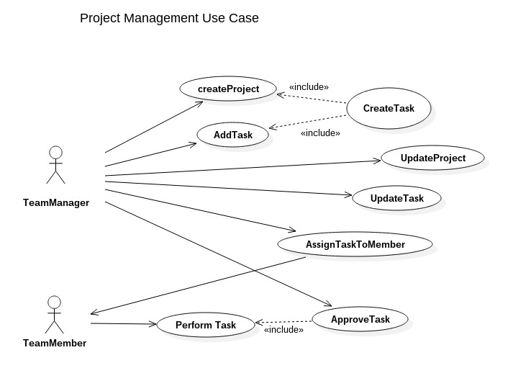

‘

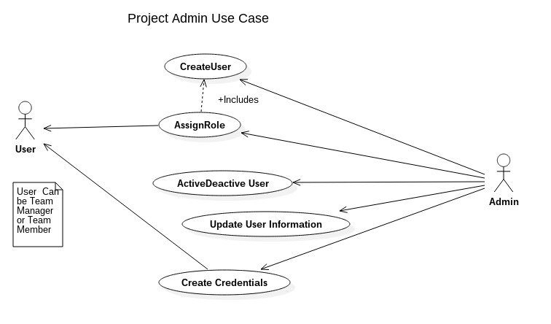

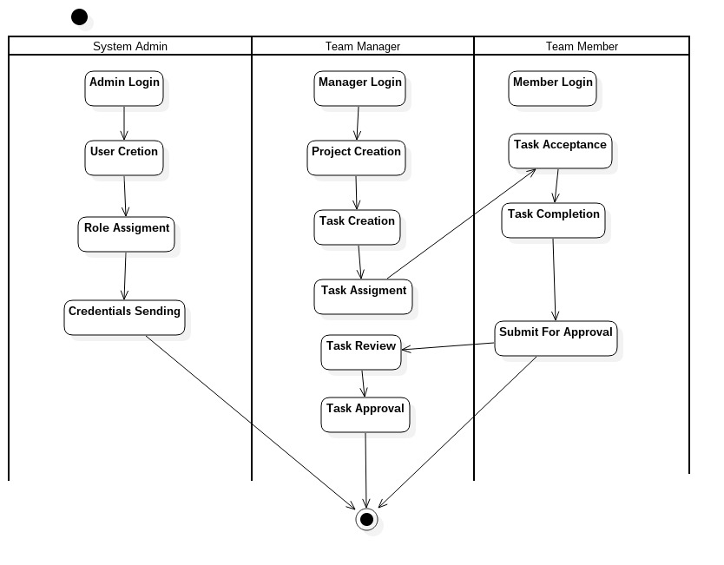

# App Snapshots

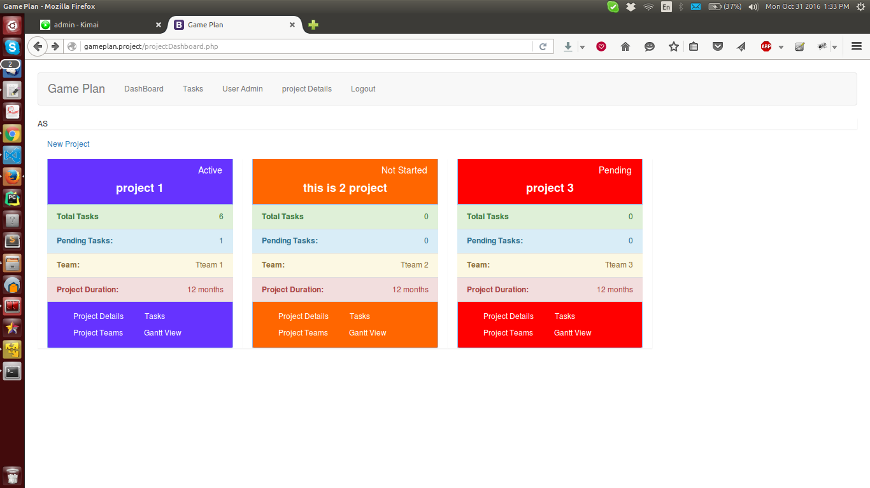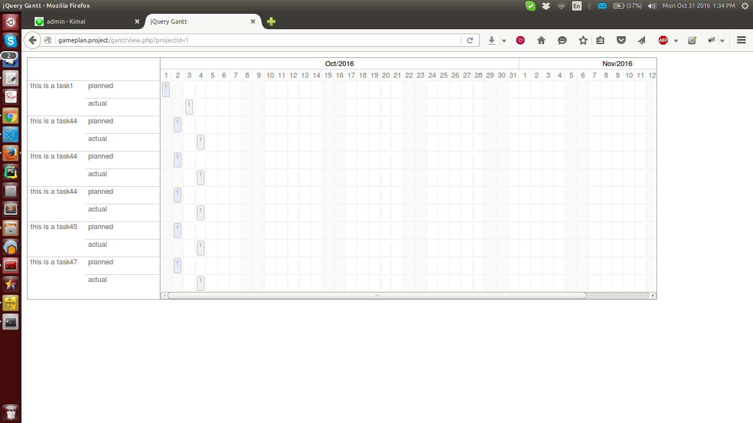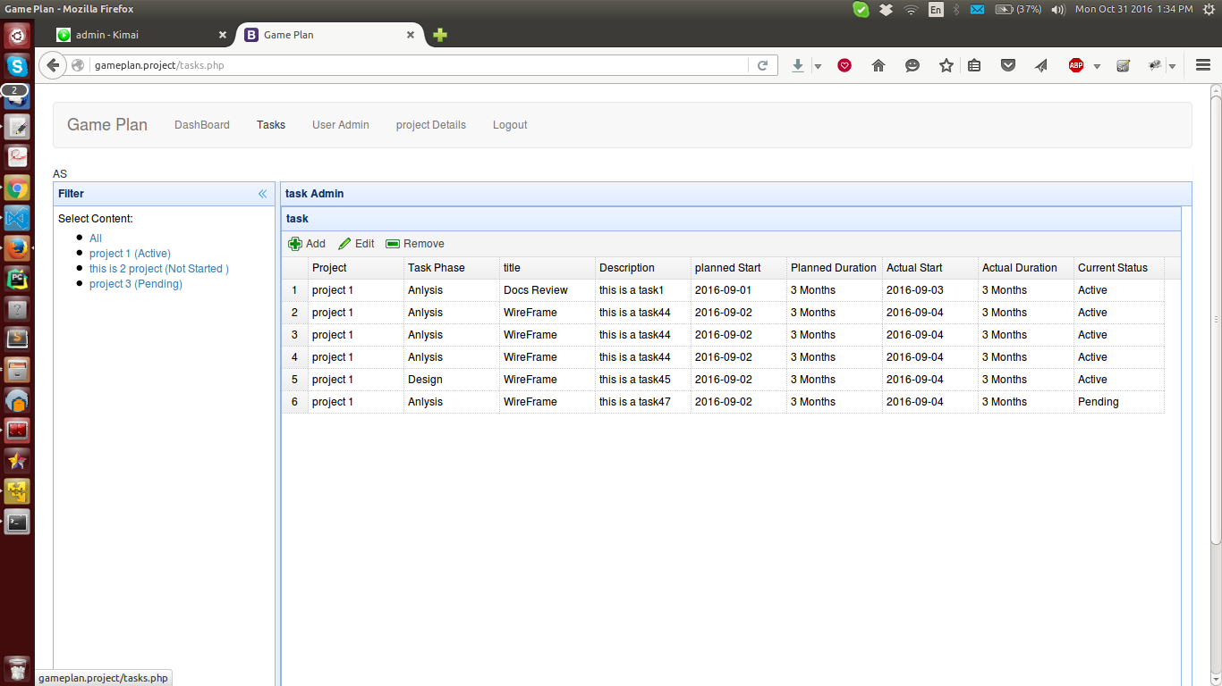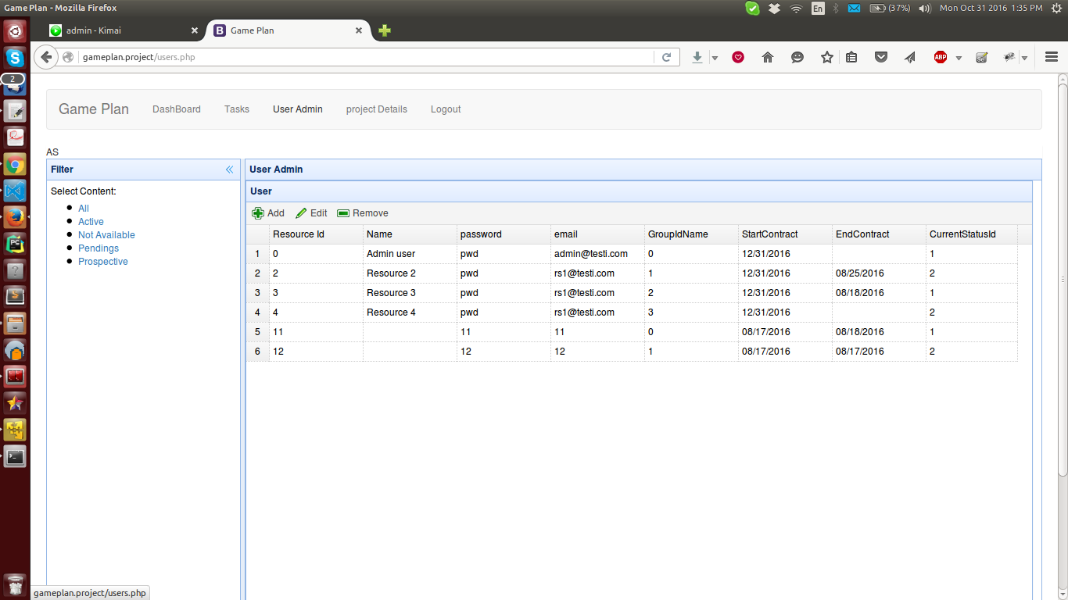

# Entity Relationship Diagram